EASTERN INTERNATIONAL UNIVERSITY Practice Assignment – Quarter 1, 2024-2025
SCHOOL OF COMPUTING Course Name: OOD
AND INFORMATION TECHNOLOGY Course Code: CSE 203
g&h Student’s Full Name:
Lab 2
Student ID:
All of labs related to coding are implemented on Visual Studio Code (VS Code) due to its lightweightness and fast running. If you are using other software, please consider switching to VSCode.
- Open VS Code
- Go to Settings à Extensions
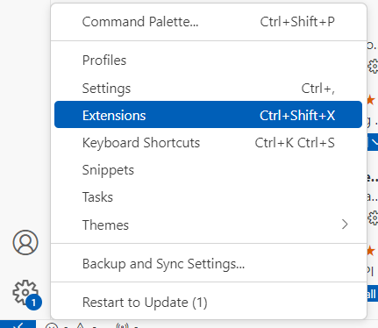
2
1
- Search for Extention Pack for Java and select result from Microsoft
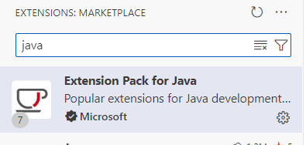
- Check if you see “Disable”, your machine has been equipped with Java extension, skip to step 6.

This is OK, you do not need to do anything. Skip to step 6
- If you see “Install” button, please press Install button. Wait till the installation finishes.
- Go to Explorer, select Create Java Project if you are not opening any folder or if there is a folder opening, right click on right side of the VS Code window, select New Java Project…
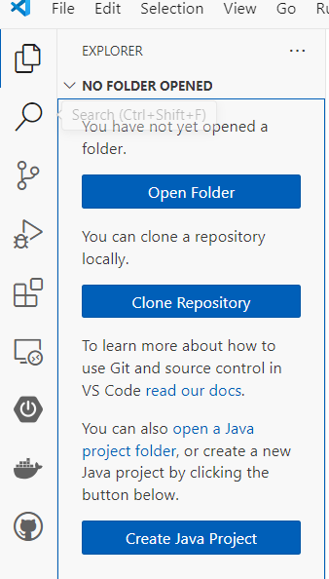
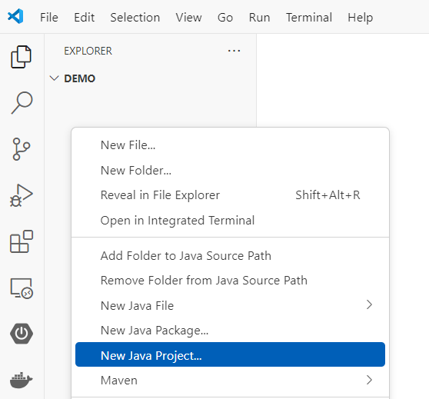
Right click on this area
- Select No build tool option (in the future, you may need to select Spring, Gradle for app or web development, JavaFX for GUI development…)
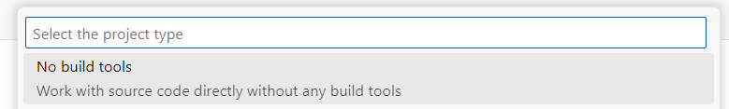
- Select the location for the project
- Type the name of the project and press Enter
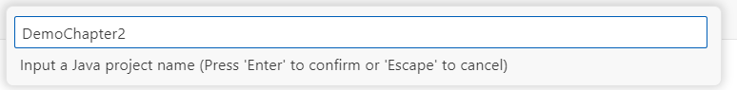
- Right click on the scr folder on right side of the VS Code window, select New Java File à Class
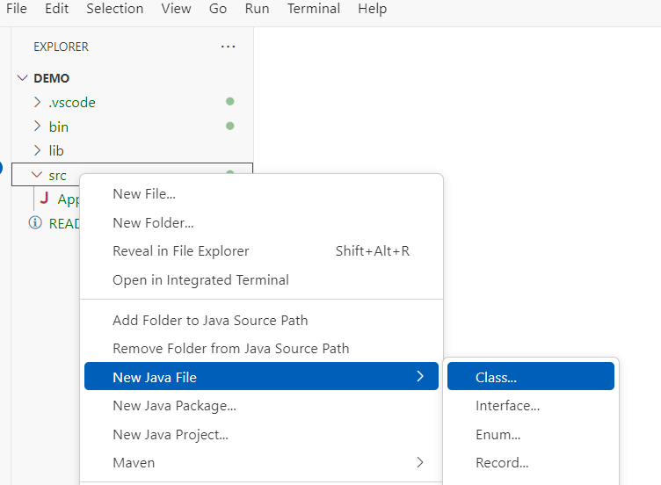
- Name your class using Java naming conventions
- Write your class in the editor window
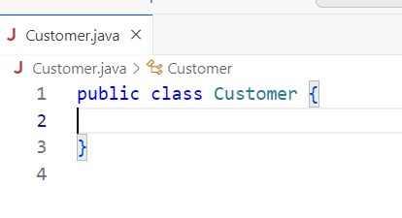
Class body goes here

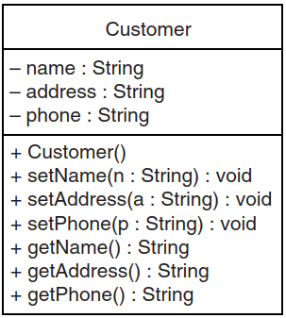
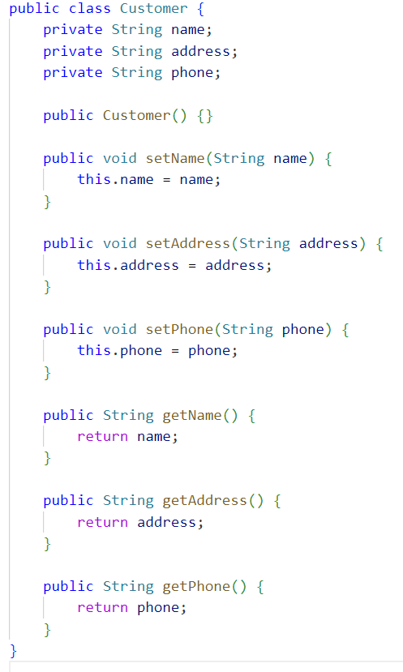
- Repeate step 9 for other classes including the demonstration class (containing the main method)
- Repeat the steps for write codes for classes in the following problems:

Employee
Design UML and write a class named Employee that has the following fields:
- name: A String object that holds the employee’s name.
- idNumber: An int variable that holds the employee’s ID number.
- department: A String object that holds the name of the department where the employee works.
- position: A String object that holds the employee’s job title.

The class should have the following constructors:
- A constructor that accepts the following values as arguments and assigns them to the appropriate fields: employee’s name, employee’s ID number, department, and position.
- A constructor that accepts the following values as arguments and assigns them to the appropriate fields: employee’s name and ID number. The department and position fields should be assigned an empty string ("").
- A no-argument constructor that assigns empty strings ("") to the name, department, and position fields, and 0 to the idNumber field.

Requirements:
- Write appropriate mutator (setter) methods to store values in these fields.
- Write accessor (getter) methods to retrieve the values from these fields.
- Write a program that creates three Employee objects to hold the following data:
Name | ID Number | Department | Position
Susan Meyers | 47899 | Accounting | Vice President
Mark Jones | 39119 | IT | Programmer
Joy Rogers | 81774 | Manufacturing | Engineer
- The program should store this data in the three objects and then display the data for each employee on the screen.

Car Class
Design UML and write a class named Car that has the following fields:
- yearModel: An int that holds the car’s year model.
- make: A String object that holds the make of the car.
- speed: An int that holds the car’s current speed.

In addition, the class should have the following constructor and other methods:
- Constructor: The constructor should accept the car’s yearModel and make as arguments. These values should be assigned to the object’s yearModel and make fields. The constructor should also assign 0 to the speed field.
- Accessors: Appropriate accessor methods should get the values stored in an object’s yearModel, make, and speed fields.
- accelerate: The accelerate method should add 5 to the speed field each time it is called.
- brake: The brake method should subtract 5 from the speed field each time it is called.
Demonstrate the class in a program that creates a Car object, and then calls the accelerate method five times. After each call to the accelerate method, get the current speed of the car and display it. Then call the brake method five times. After each call to the brake method, get the current speed of the car and display it. You can use for loop for simulating these methods.

Temperature Class
Write a Temperature class that will hold a temperature in Fahrenheit, and provide methods to get the temperature in Fahrenheit, Celsius, and Kelvin. The class should have the following field:
- ftemp: A double that holds a Fahrenheit temperature.

The class should have the following methods:
- Constructor: The constructor accepts a Fahrenheit temperature (as a double) and stores it in the ftemp field.
- setFahrenheit: The setFahrenheit method accepts a Fahrenheit temperature (as a double) and stores it in the ftemp field.
- getFahrenheit: Returns the value of the ftemp field, as a Fahrenheit temperature (no conversion required).
- getCelsius: Returns the value of the ftemp field converted to Celsius.
- getKelvin: Returns the value of the ftemp field converted to Kelvin.

Use the following formulas:
- To convert Fahrenheit temperature to Celsius:
$$Celsius= \frac{5}{9} × (Fahrenheit-32)$$
- To convert Fahrenheit temperature to Kelvin:
$$Kelvin= \left(\frac{5}{9}×(Fahrenheit-32)\right) +273$$
Demonstrate the Temperature class by writing a separate program that:
- Asks the user for a Fahrenheit temperature.
- Creates an instance of the Temperature class with the value entered by the user passed to the constructor.
- Uses the object’s methods to display the temperature in Celsius and Kelvin.

SavingsAccount Class
Design a SavingsAccount class that stores a savings account’s annual interest rate and balance. The class constructor should accept the amount of the savings account’s starting balance. The class should also have methods for:
- Subtracting the amount of a withdrawal.
- Adding the amount of a deposit.
- Adding the amount of monthly interest to the balance.
The monthly interest rate is the annual interest rate divided by twelve.
To add the monthly interest to the balance:
- Multiply the monthly interest rate by the balance.
- Add the result to the balance.
Test the class in a program that calculates the balance of a savings account at the end of a period of time. The program should:
- Ask the user for:
  - The annual interest rate.
  - The starting balance.
  - The number of months that have passed since the account was established.
- Iterate once for every month, performing the following:
  - Ask the user for the amount deposited into the account during the month. Use the class method to add this amount to the account balance.
  - Ask the user for the amount withdrawn from the account during the month. Use the class method to subtract this amount from the account balance.
  - Use the class method to calculate the monthly interest.
After the last iteration, the program should display:
- The ending balance.
- The total amount of deposits.
- The total amount of withdrawals.
- The total interest earned.

Pet Grooming Shop
Bella’s Pet Grooming Shop specializes in grooming dogs and cats. When a customer brings a pet to the shop, the groomer gets the customer's name, address, and phone number. The groomer then records the pet's breed, age, and weight, and provides the customer with a service estimate. The service estimate includes the cost of grooming services, additional care charges, and the total cost including sales tax.

Delights Bakery
Sweet Delights Bakery takes custom cake orders for events such as weddings and birthdays. When a customer places an order, the baker collects the customer’s name, address, and phone number. The baker then records the type of cake, the number of tiers, and the event date, and provides the customer with a price quote. The price quote includes the cost of ingredients, labor charges, and delivery fee, plus the total amount including sales tax.

Car Rentals
Speedy Car Rentals rents out cars to customers for personal and business use. When a customer rents a car, the rental agent records the customer’s name, address, and driver’s license number. The agent then notes the make and model of the car being rented, the rental period, and the mileage limit, and provides the customer with a rental agreement. The rental agreement includes the base rental fee, any applicable mileage fees, and the total rental cost including taxes.

Photography Studio
Shutterbug Photography Studio offers photoshoots for families and events. When a customer books a session, the photographer collects the customer’s name, address, and phone number. The photographer also records the type of session (e.g., family, wedding, portrait), the session duration, and the date. A booking confirmation is provided, which includes the base session fee, any additional charges for editing, and the total price including sales tax.

Library
EIU Library offers printed books for borrowing. When a user wants to borrow a book, they first check if it is available. If available, the user provides the ISBN, title, and the number of days they want to borrow the book to the librarian. The librarian then verifies the user’s ID, name, and email address, and checks the list of books the user is currently holding. If the user has more than one overdue book, they cannot borrow any more books. If the student is eligible for borrowing the book, a new borrowing record which contains borrowing user, borrowed book, borrowing date, and due date (based on the number of days that the user wants to borrow) will be created and saved in a list for borrowing history management.

Submit: Must include:
- a pdf file containing your information (student id, name), and images of the class diagrams, codes, answers
- and all source code files (if any)
in a zipped (.zip or *.rar) file to moodle

